

**International University of Business Agriculture and Technology**

**(IUBAT University)**

**Report**

**on**

**“Employee Payroll Management System”**

**Prepared For:**

**Safwana Haque**

Course Instructor

Department of Computer Science and Engineering

IUBAT University

**Prepared By:**

**Group** –**06**

**Sec: A**

**Fall 2017**

**Group Members**

|  |  |  |
| --- | --- | --- |
| Serial | Name | ID |
| 01 | Md. Faiyaj Zaman | 14303125 |
| 02 | Didarul Amin | 17103192 |
| 03 | Asif Iftekher Pial | 16103129 |
| 04 | Mehanaz Sultana | 14303020 |
| 05 | Md. Faridul Islam | 14303036 |

Table of Contents

1.

1.1 Software requirements 4

1.2 Aims and objectives 4

2. Design and Implementation 5

2.1 Design Approach 5

2.2 UML Class Diagrams 5

2.2.1 Login.java 5

2.2.3 MainMenu.java 6

2.2.4 User.java 8

2.3 Database and Table Design 9

2.4 Graphical User Interface Implementation 10

2.5 Application Innovation 12

4. Critical Evaluation 15

Bugs or Weakness 15

Strong points and novel Features 15

5. Bibliography 16

1. **Introduction**

This project is about employee payroll management system.This software facilitates management in monthly salary of the employee and the information of the employee. We tried here with our little afford to make application which works in a same way like other employee payroll management system does. Here we have GUI for the Account Managerso that he feels comfortable to use it.

### 1.1Software requirements

The main feature of this application is to take the data from user and keep the data save and allow to access when needed.

1. Very simple design so that general people who has minimum knowledge about computer can use this software.
2. Most of the pages background is white so that the texts are written in the page can be read easily.
3. The text fields and the levels are merged in an organized way.
4. Easy Identification of all material so that user can find it easily.
5. Storage and preservation no risk of data lost.
6. Easy to Handle Materials.
7. Easy for calculating the salary for each employee.
8. Password protected for User.

### 1.2 Aims and objectives

The main objective of this application is storing all kind of information of products stored in the warehouse for example: product price, type, interest calculating, PDF generating etc.

1. It has a secure log in facilities.
2. Insert, update, and delete& other option for product and customer’s basic info.
3. It can also product images in database.
4. It can also generate PDF of the employees list and salary and customer information.

# 2.Design and Implementation

## 2.1- Design Approach

After logging in as user or admin rest of the work can be done in very easy way.

1. If user logged in then he can control the software.
2. User can insert new user from the Add user page.
3. All the user can do the same thing.
4. User can keep a record of information through Audit Trail.

## 2.2 UML Class Diagrams

UML Class Diagram describes the structure of a system by modeling its classes, attributes, and operations. They also clearly show the relationship between objects. UML diagrams are language independent. UML diagrams use an independent notation to show return types, access modifiers, etc.

### 2.2.1 Login.java

Login.java is the first page of the software. In the Login.java page there is the main method of this java program. A User have to login from this page to use this software.

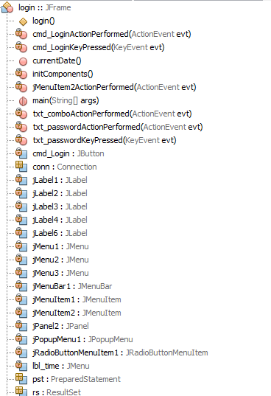

Figure 2.2.1

.

### 2.2.3 MainMenu.java

In this page usercan see all the information of employee.

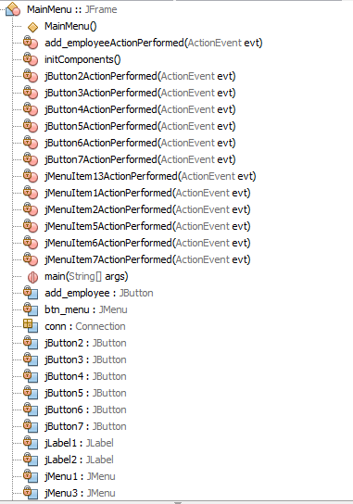

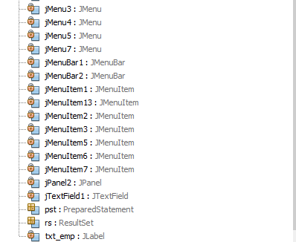

Figure 2.2.3.

### 

### 2.2.4 User.java

Here we can see the User activities

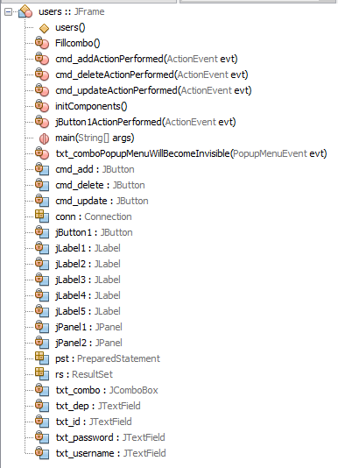

Figure 2.2.4

## 2.3 Database and Table Design

If we want to build an application that retrieves or stores data in a database so we need to learn about database connectivity in Java. Java connects to databases using JDBC. We learned it through Java.

1. Database for managing employee.

**Figure 2.3.1**

2.Database for user & admin login

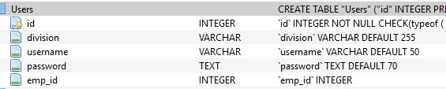

**Figure 2.3.2**

## 2.4 Graphical User Interface Implementation

1. The first page of our software is login page from where user will login into the software.

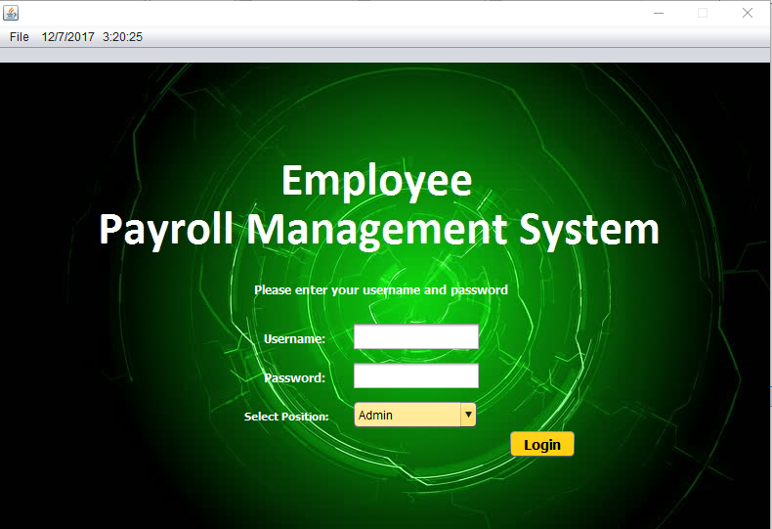

Figure 2.4.1

If the username or password is not correct then a pop-up message will show that the user id or password is not correct.

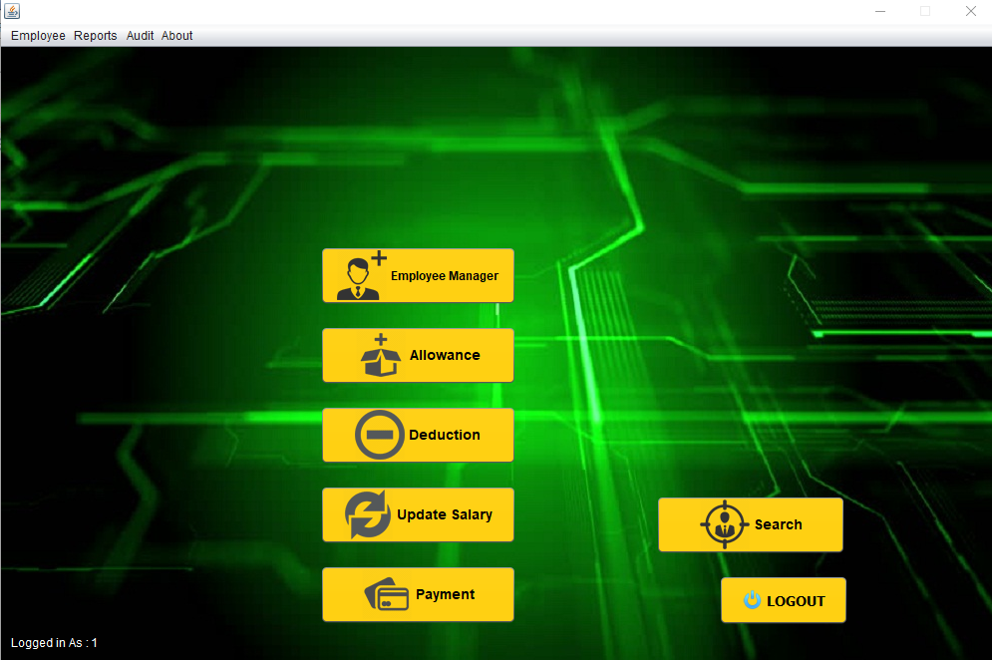

Figure 2.4.2

3. In the MainMenu page user can see all the employee information.

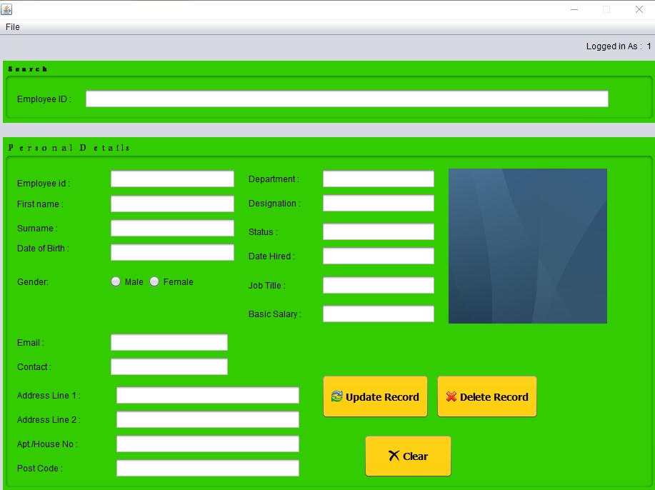

Figure 2.4.3

# 

# 2.5 Application Innovation

We have built solutions that have helped companieseployer salary and information.

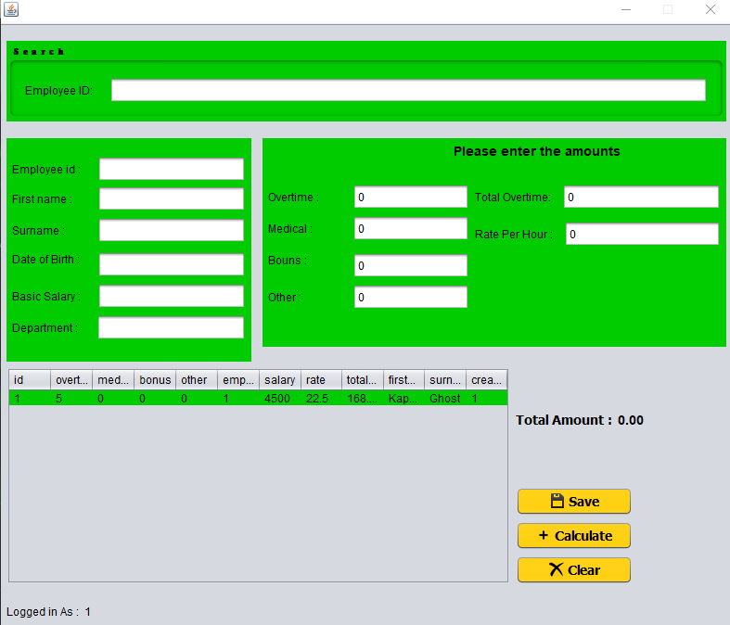

**Figure2.5.1**

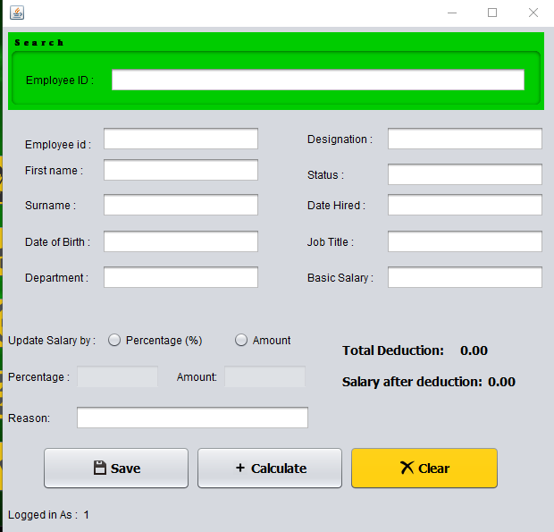

Fig:3.1

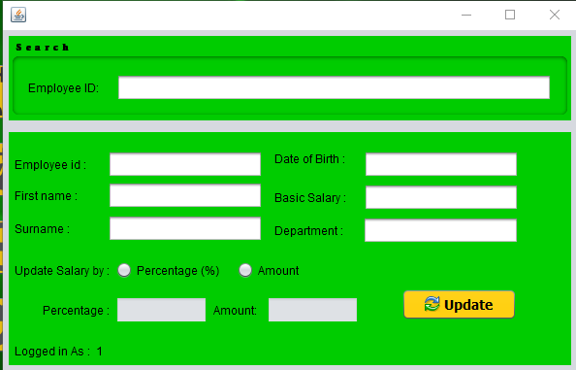

Fig:3.2

# 4. Critical Evaluation

## Bugs or Weakness

1. The pages are not responsive that means the page does not change its shape when the tab is minimized and restored.
2. The application does not import the database itself. The user has to import the database and then he can run the application.
3. No internet advantages.
4. No purchase Department and various suppliers.
5. Basic PDF generation.

## Strong points and novel Features

1. Easy Identification of all material stored.
2. Receipt of incoming goods.
3. Inspection of all receipts.
4. Storage and preservation.
5. Easy to Handle Materials.

# 5.Refference

WebSite Are:

1. <https://www.developer.com/java/creating-a-jdbc-gui-application.html>

2.<https://www.javatpoint.com/java-jdbc>

3.<https://www.javatpoint.com/>

4.<https://www.youtube.com/>